**Introduction to Tableau**

**LAB REPORT # 4**



**Fall 2023**

**Data Analytics Lab**

Submitted by:

**Maaz Habib**

Registration No.:

**20PWCSE1952**

Class Section:

**C**

“On my honor, as student of University of Engineering and Technology, I have neither given nor received unauthorized assistance on this academic work.”

Submitted to:

**Ma’am Madiha**

February 4, 2024

Department of Computer Systems Engineering

**University of Engineering and Technology, Peshawar**

**Introduction to Tableau**

***---------------------------TASK#1-----------------------------***

Tableau has been installed properly on trial of 14 days

***---------------------------TASK#2----------------------------***

***Importing Data***

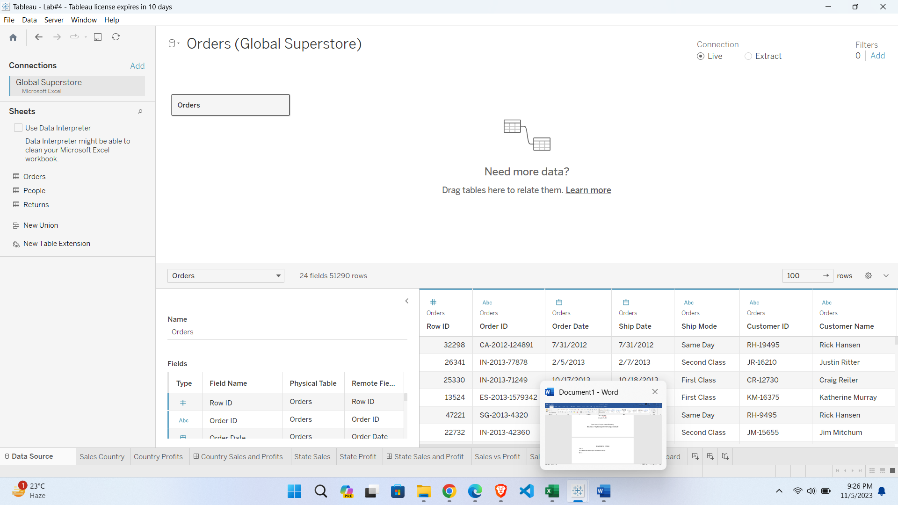

***---------------------------TASK#3-----------------------------***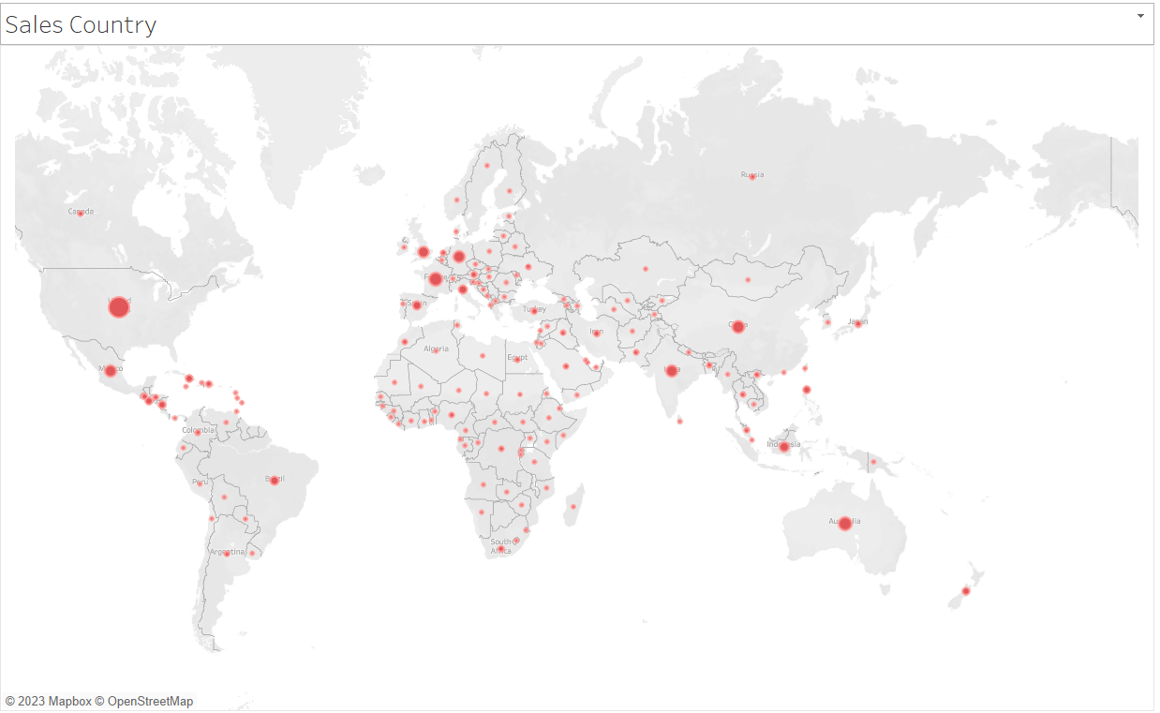

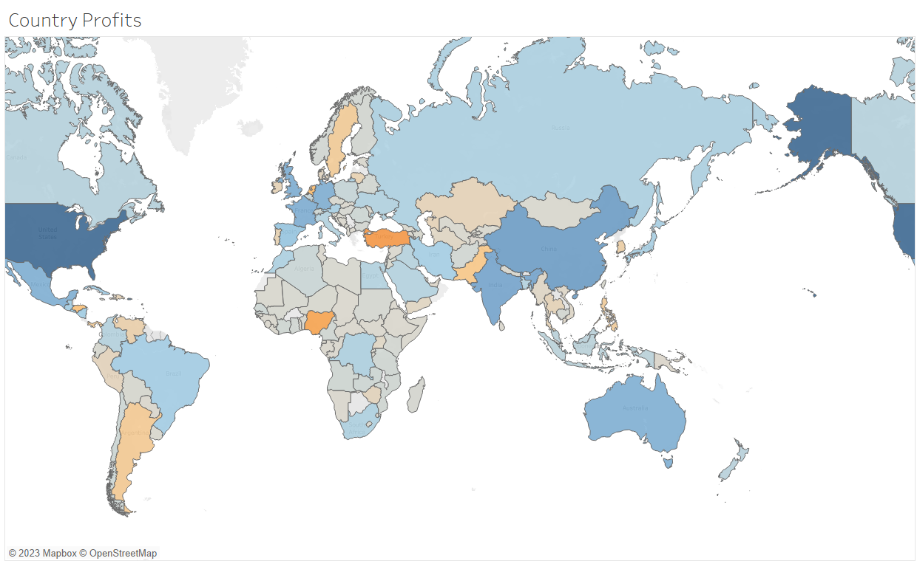

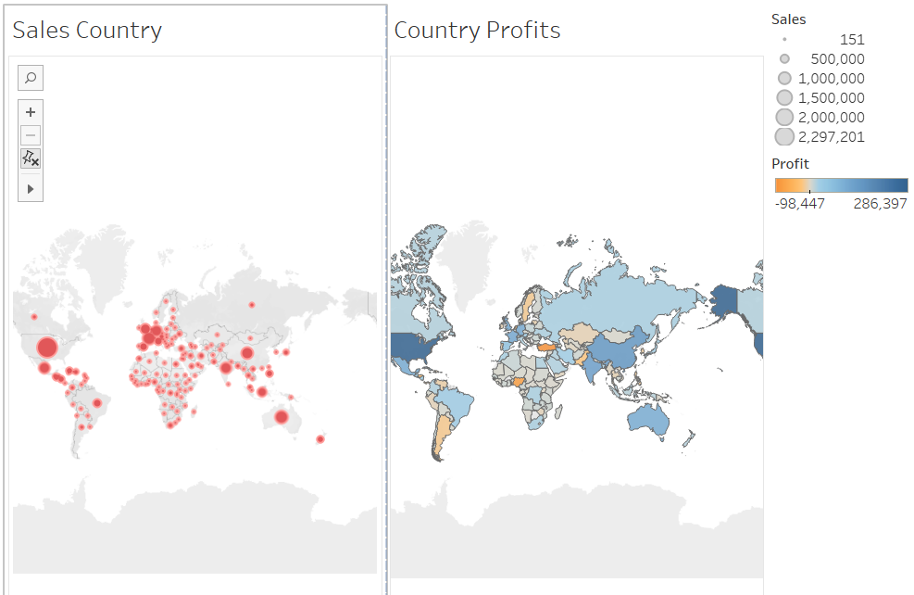

***---------------------------TASK#4-----------------------------***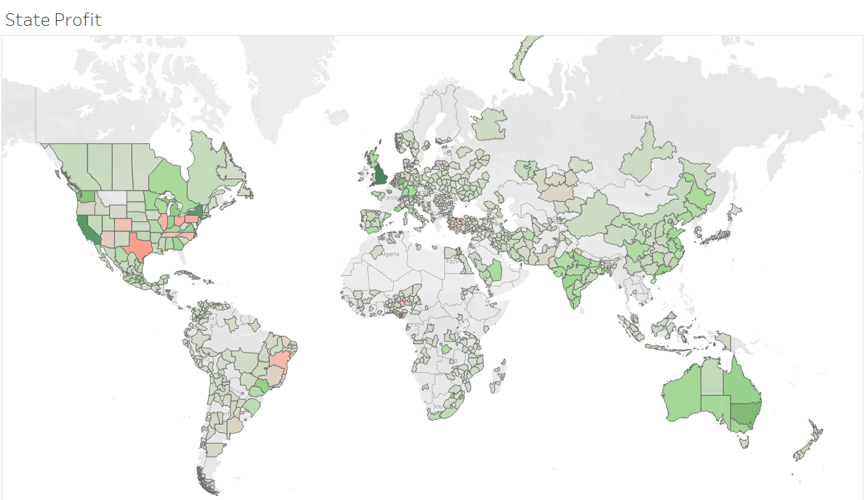

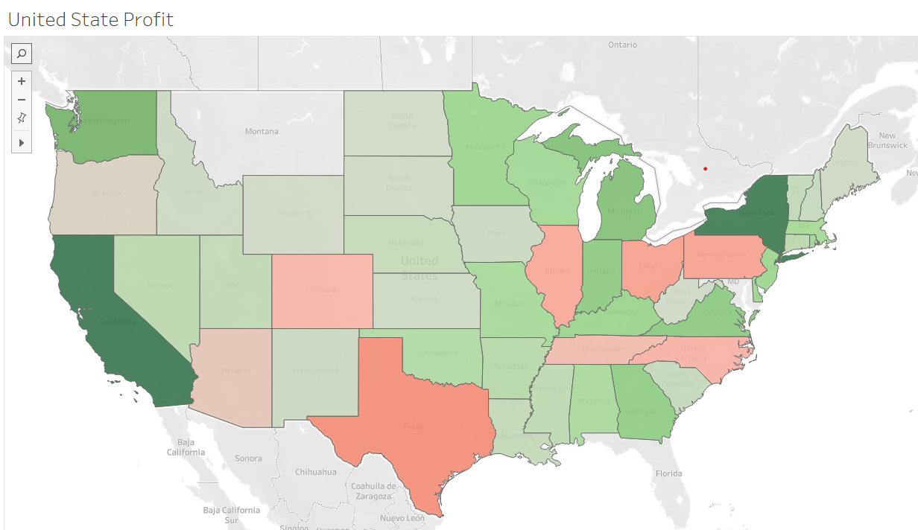

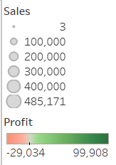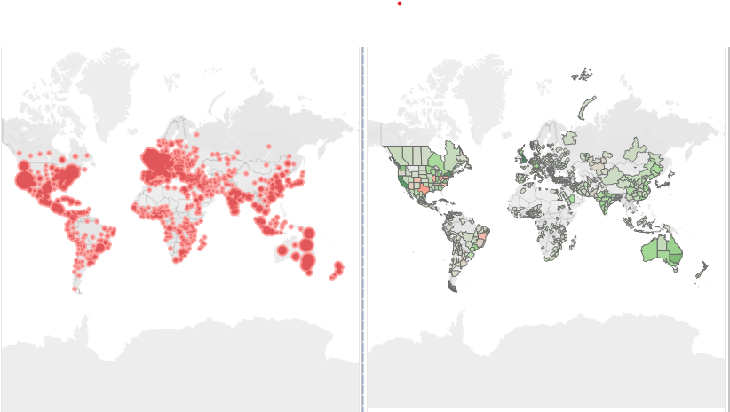

***---------------------------TASK#5-----------------------------***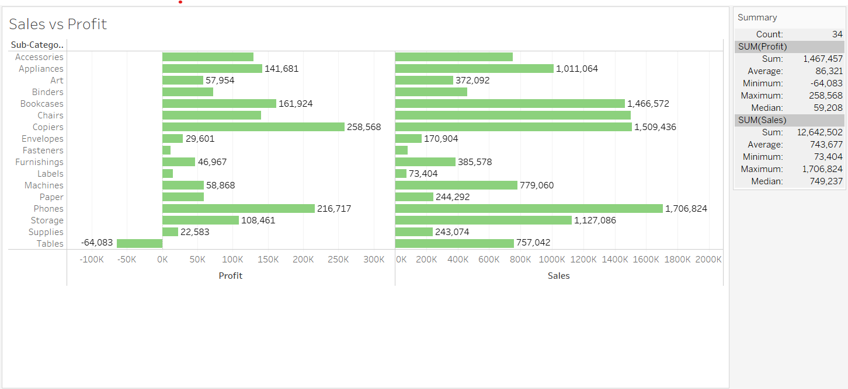

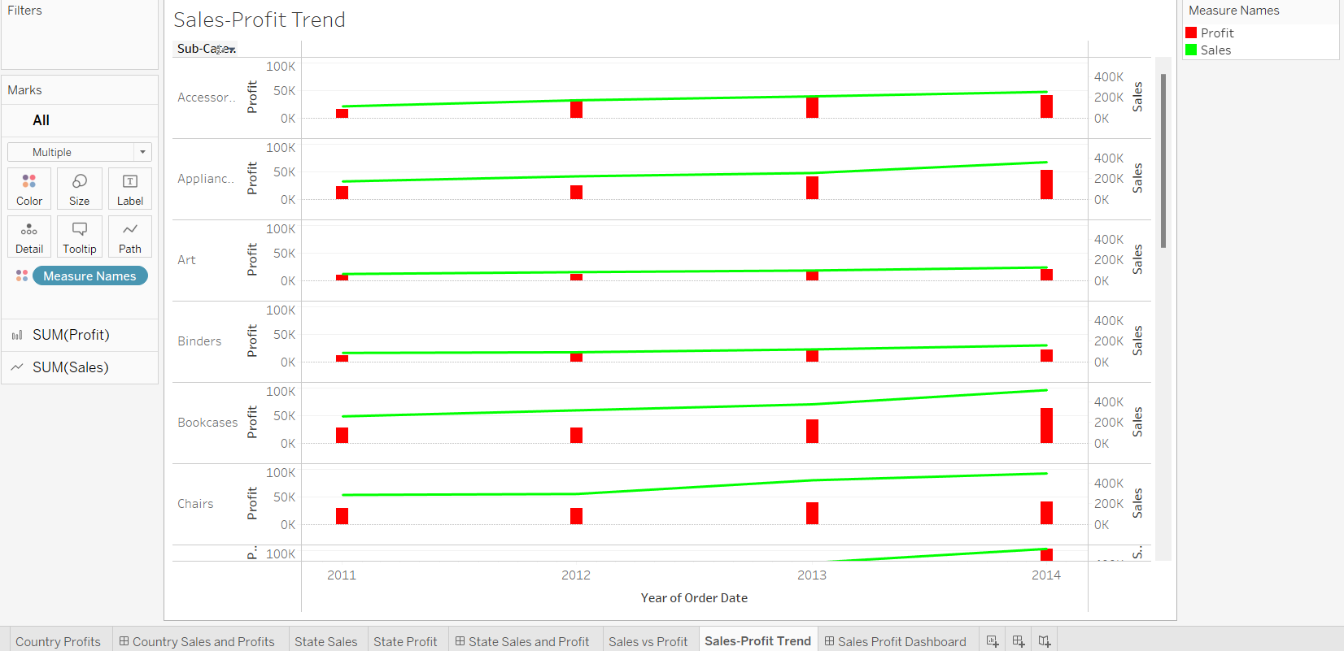

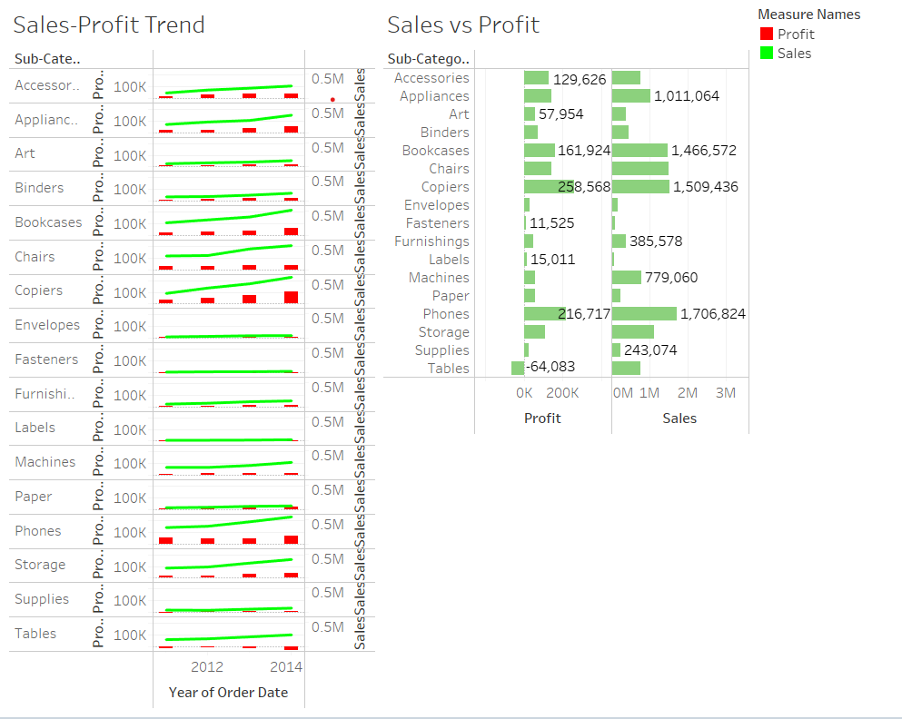

***---------------------------TASK#6-----------------------------***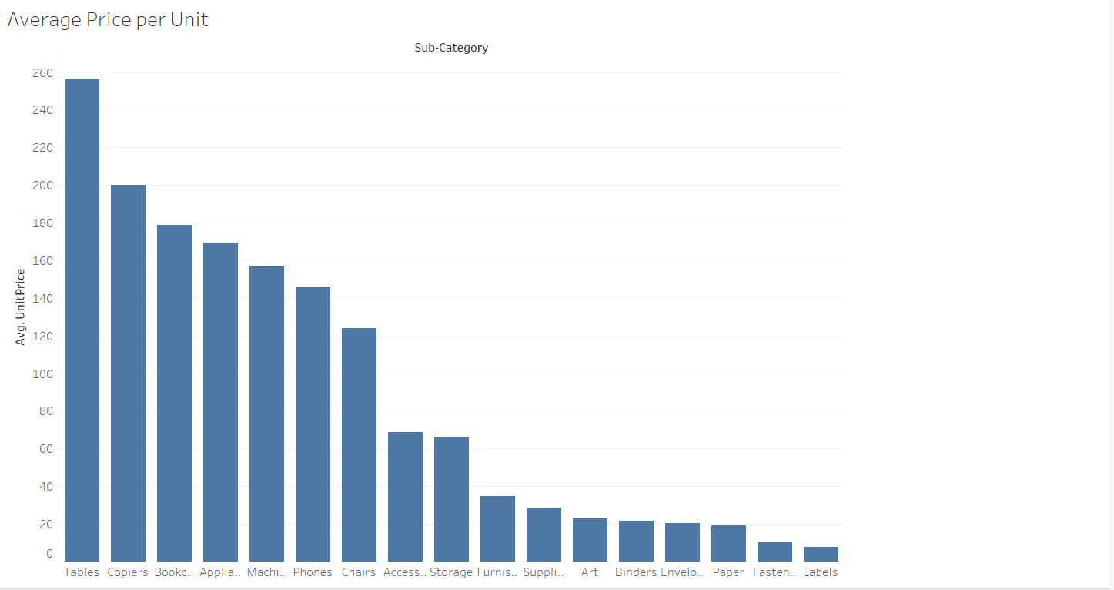

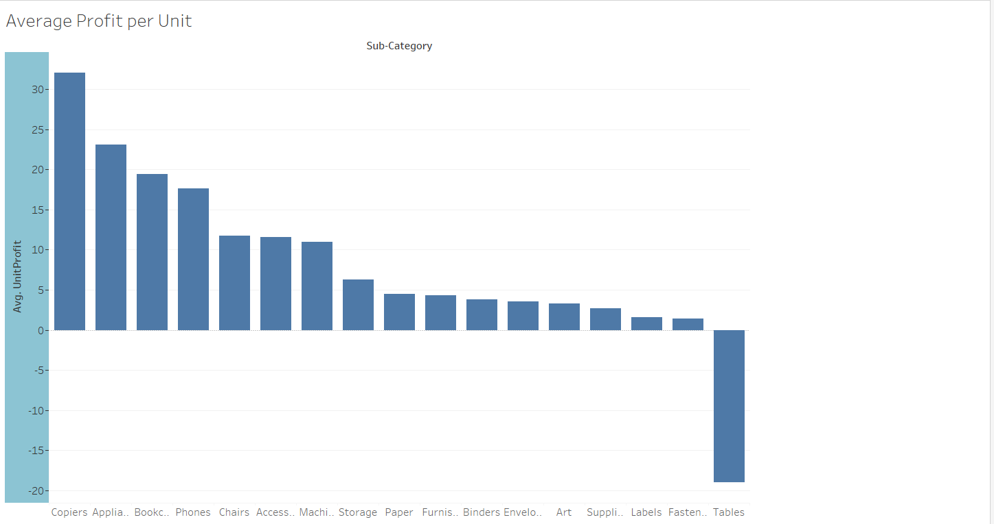

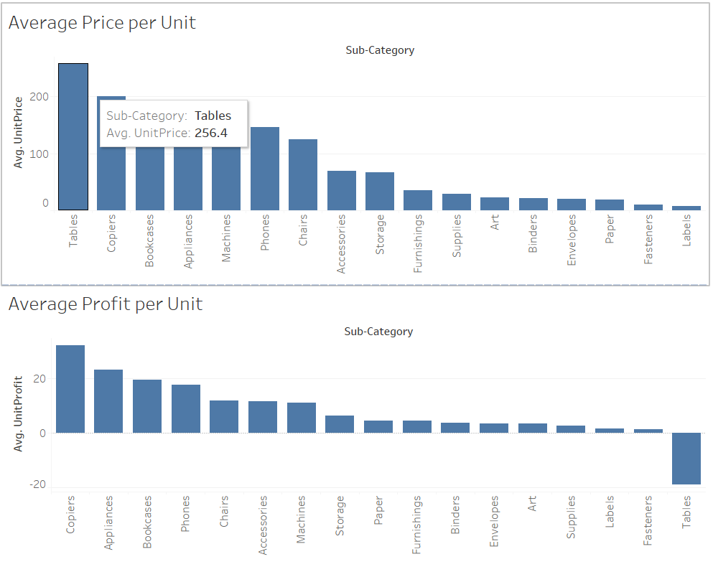

***---------------------------TASK#7-----------------------------***

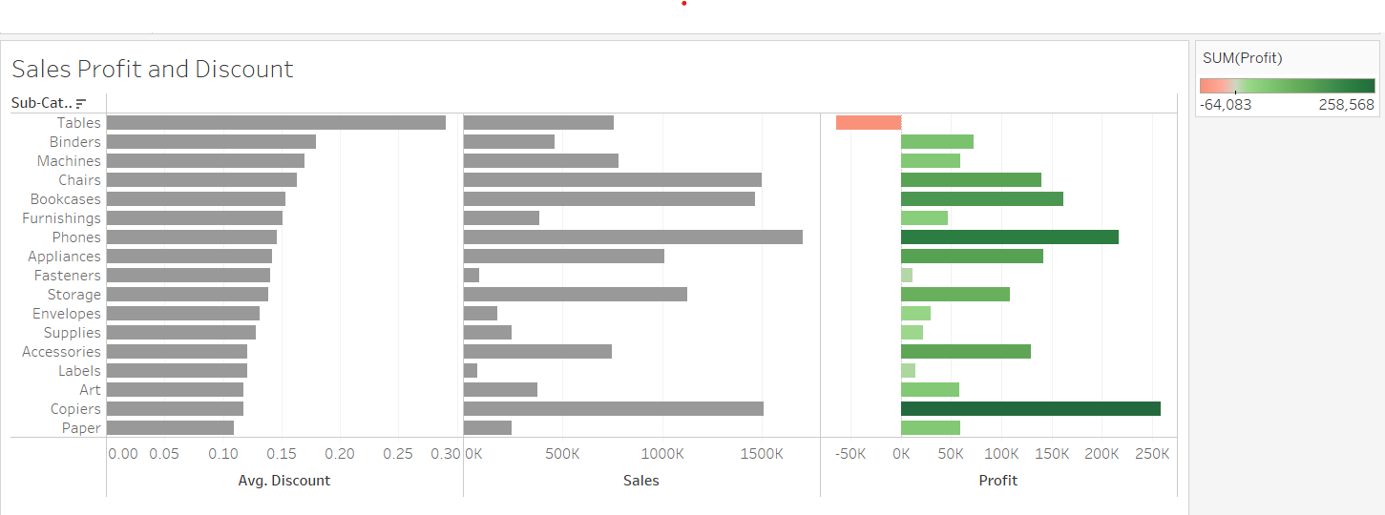

***---------------------------TASK#8-----------------------------***

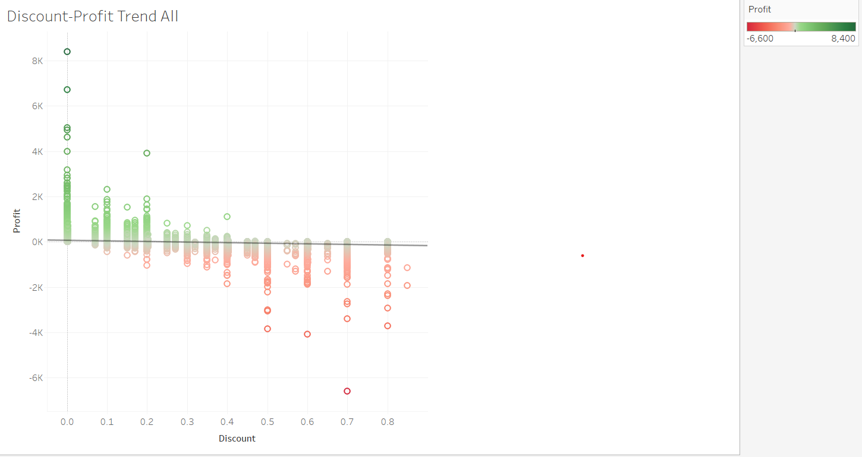

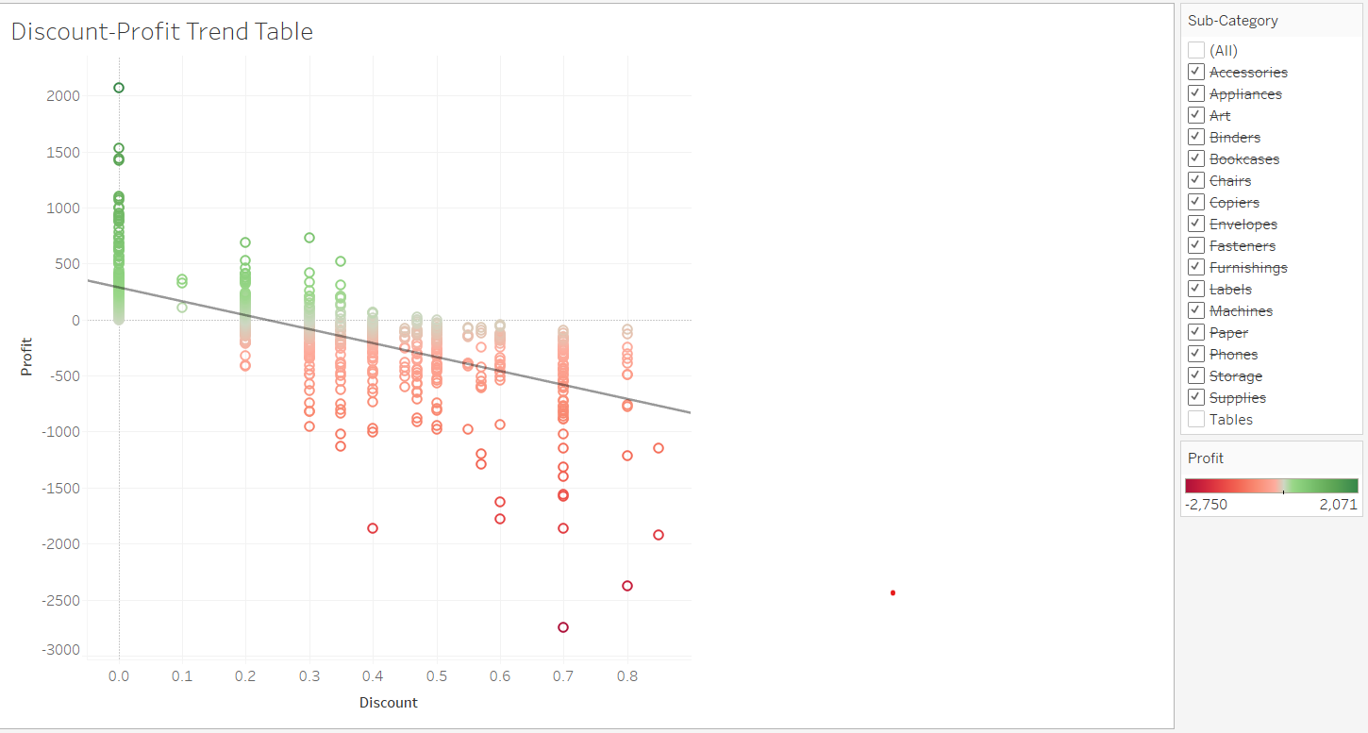

***---------------------------TASK#9-----------------------------***

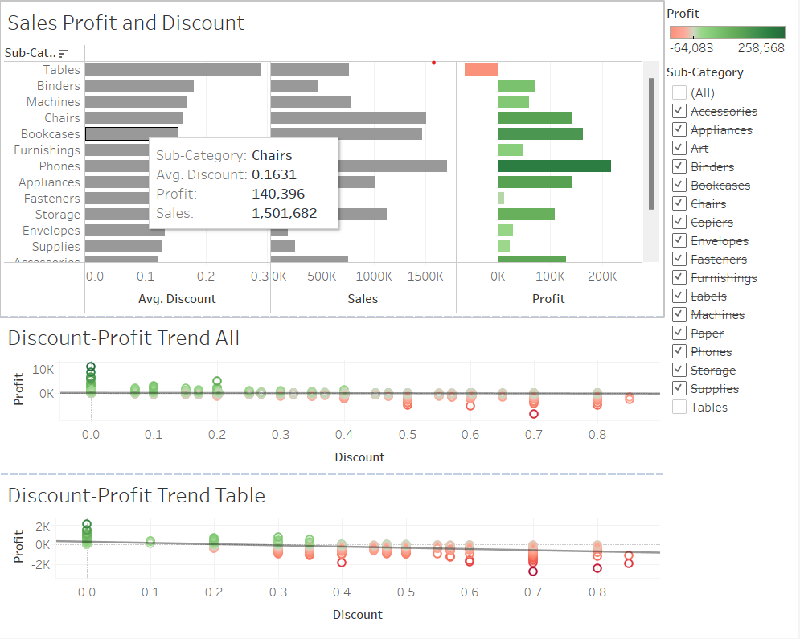

***---------------------------TASK#10-----------------------------***